LEVEL 1 — QUANT FOUNDATIONS TRACK
Mathematical Foundations
Expanded Reference Edition
This is the expanded reference edition of the five Level 1 topics that open the curriculum's Mathematical Foundations track. Each topic keeps its original learning-position summary and then goes substantially deeper: concept walkthroughs explaining the intuition, fully worked numerical examples, and reference tables of the key formulas. Where a topic's full depth belongs to a later level (as with Stochastic Mathematics), that boundary is stated explicitly rather than glossed over.

Table of Contents
Right-click and choose "Update Field" (or "Update entire table") after opening in Word to populate page numbers.
Table of Contents 1
1. Arithmetic & Algebra for Finance (Level 1) 1
1.1 Learning Position at a Glance 1
1.2 Concept Walkthrough 1
1.3 Worked Example — Simple vs. Log Returns Over Three Periods 1
1.4 Worked Example — Converting Between Rate Conventions 1
1.5 Reference Table — Key Formulas 1
2. Calculus (Level 1) 1
2.1 Learning Position at a Glance 1
2.2 Concept Walkthrough 1
2.3 Worked Example — Taylor Approximation of Option P&L 1
2.4 Worked Example — Gradient of a Two-Factor P&L Function 1
2.5 Reference Table — Key Formulas 1
3. Linear Algebra (Level 1) 1
3.1 Learning Position at a Glance 1
3.2 Concept Walkthrough 1
3.3 Worked Example — Two-Asset Portfolio Variance 1
3.4 Worked Example — Eigenvalues and Eigenvectors of a 2×2 Covariance Matrix 1
3.5 Reference Table — Key Formulas 1
4. Optimisation (Level 1) 1
4.1 Learning Position at a Glance 1
4.2 Concept Walkthrough 1
4.3 Worked Example — Minimum-Variance Weights, Unconstrained vs. Long-Only 1
4.4 Worked Example — Deriving the Minimum-Variance Weight with a Lagrange Multiplier 1
4.5 Reference Table — Key Formulas 1
5. Stochastic Mathematics (Introductory Awareness Only) (Level 1 (awareness) → Level 5 (depth)) 1
5.1 Learning Position at a Glance 1
5.2 Concept Walkthrough 1
5.3 Worked Example — Discrete Random Walk as a Precursor to Brownian Motion 1
5.4 Worked Example — Why the Random Walk's Spread Grows with √n, not n 1
5.5 Reference Table — Key Formulas 1

1. Arithmetic & Algebra for Finance (Level 1)
Covers: Fractions · percentages · ratios · basis points · compounding · logarithms · exponents · equations · functions · exponential/log functions · rearranging formulas
▸ INTUITION FIRST
Compounding is multiplication, not addition. Every time a beginner adds percentages across time, they are silently assuming compounding doesn't exist. Logarithms are the tool that turns multiplication back into addition — that single fact explains almost every log-return formula you will encounter.

1.1 Learning Position at a Glance
- What it is: The pre-calculus toolkit used constantly in finance: percentage changes, compounding, and manipulating formulas.
- Why it matters: Returns, interest rates and volatility scaling are all built from compounding and logarithms; weakness here undermines everything above it.
- Prerequisites: None (this is the true starting point).
- Connects to Research: Log returns (used almost universally in research) require comfort with logarithms and their additive properties.
- Connects to Development: Basis-point and percentage formatting bugs are a common, avoidable source of production errors.
- Connects to Trading: Basis points are the native unit of quoted spreads, fees and rate moves.
- Practical exercise: Derive, from first principles, why log returns are additive across time but simple returns are not, using a 3-period compounding example.
- Common beginner mistakes:
  - Adding simple (arithmetic) returns across time instead of compounding them.
  - Confusing basis points (1bp = 0.01%) with percentage points.
- Advanced extensions: Continuous compounding as the limiting case, connecting directly into calculus.
- Professional applications: Return annualisation; interest-rate conversions; fee/cost accounting.

1.2 Concept Walkthrough
The reason finance leans so heavily on logarithms rather than raw percentages comes down to one property: additivity. If a portfolio returns +10% in period one and –10% in period two, the simple (arithmetic) returns sum to 0%, but the investor is not back to break-even — they are down 1% (1.10 × 0.90 = 0.99). Log returns fix this: ln(1.10) + ln(0.90) = ln(0.99), which correctly reflects the compounded outcome. This is why almost every research pipeline works in log-return space rather than simple-return space.
The deeper reason this works is that a logarithm converts multiplication into addition: ln(a × b) = ln(a) + ln(b). Since compounding wealth over time is fundamentally a multiplicative process — successive growth factors are multiplied together, never added — taking logs turns the whole problem into simple addition. Cumulative log return over any horizon is just the sum of the period log returns, with no compounding formula required. This is the single algebraic identity underlying nearly every return-series calculation in quantitative research.
Basis points (bps) are simply a convenient decimal shift: 1 bp = 0.01% = 0.0001. They exist because rates, spreads and fees are usually too small to discuss comfortably in percentage terms — a 5-bp change in a bond yield is much easier to communicate than “0.05 percentage points.” The most common beginner error is treating a move “from 2% to 3%” as “1 bp” instead of the correct 100 bp (one percentage point = 100 basis points).
Compounding itself is best understood as repeated multiplication by a growth factor (1 + r). The chart below makes the effect visible: a naive “add the rate every period” model (the dashed line) understates true growth more and more as time passes, because it never lets past interest earn its own interest. The gap between the two curves is not a rounding error — it grows without bound as the horizon lengthens, which is exactly why long-horizon return figures must always be compounded, never added.
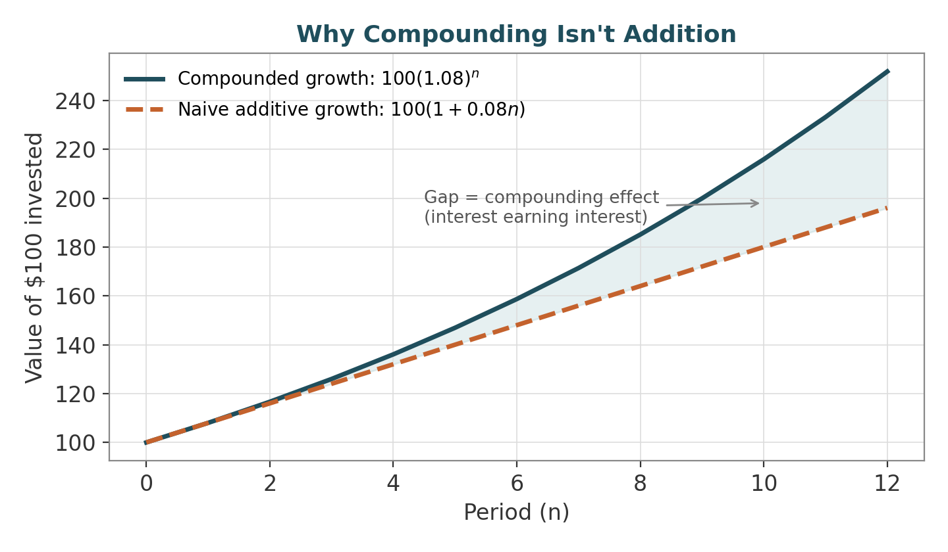
Figure 1.1 — Compounded growth pulls away from naive additive growth because each period's interest itself earns interest in subsequent periods.

1.3 Worked Example — Simple vs. Log Returns Over Three Periods
- A position has the following period returns: Period 1: +8%, Period 2: −5%, Period 3: +4%.
- Simple-return (incorrect) approach: sum the returns directly → 8% − 5% + 4% = 7%. This looks like a 7% total gain, but it is not what actually happened to the investor's capital.
- Correct compounding approach: multiply the growth factors → 1.08 × 0.95 × 1.04 = 1.06704, i.e. a true cumulative return of 6.704%.
- Log-return approach: ln(1.08) + ln(0.95) + ln(1.04) = 0.07696 − 0.05129 + 0.03922 = 0.06489. Converting back: e^0.06489 − 1 = 6.704% — matching the compounded figure exactly, because log returns are additive by construction.
- Takeaway: simple returns can be added only as an approximation for very small moves; log returns can always be added, which is why they are the default unit in return-series research.
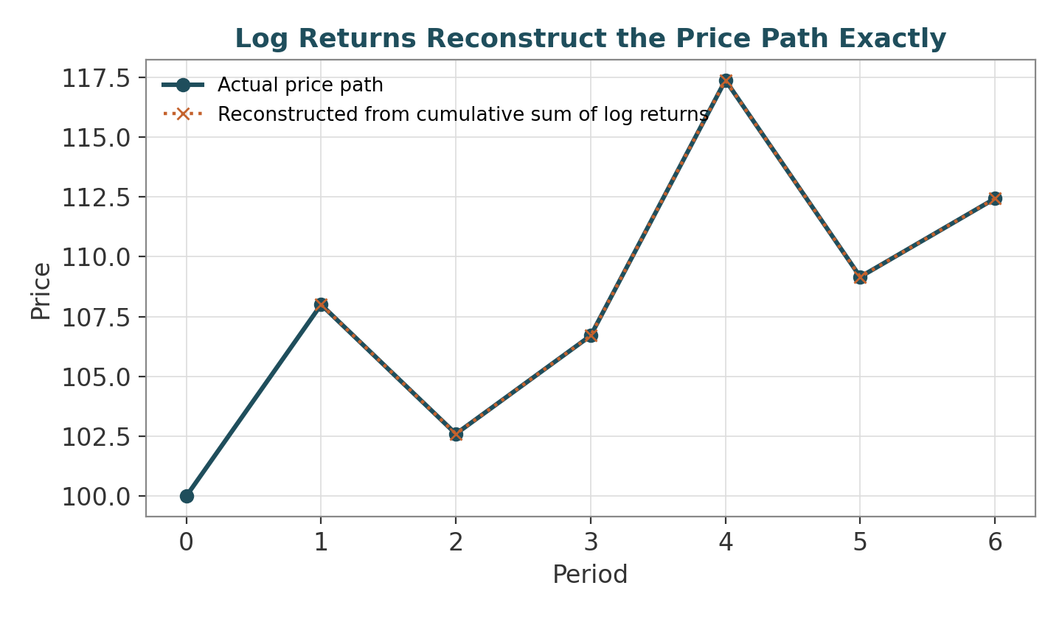
Figure 1.2 — Summing log returns and exponentiating reconstructs the exact price path; summing simple returns would not.

1.4 Worked Example — Converting Between Rate Conventions
- A bank quotes a savings rate of 6% “compounded monthly.” To compare it with a rate quoted annually, first find the true effective annual rate (EAR): EAR = (1 + 0.06/12)¹² − 1 = (1.005)¹² − 1 ≈ 6.168%.
- Notice this is higher than the quoted 6% — monthly compounding lets interest earn interest eleven times within the year, which the simple annual figure hides.
- To express the same rate as a continuously compounded rate r_c, solve e^{r_c} = 1.06168, so r_c = ln(1.06168) ≈ 5.988%. Continuous compounding is always the lowest-looking rate for a given effective growth, because it is compounding in the limit of infinitely many periods.
- This kind of conversion is routine whenever comparing instruments quoted on different conventions (monthly bank rates, semi-annual bond coupons, continuously compounded option-pricing rates) — getting it wrong silently misprices the comparison.

1.5 Reference Table — Key Formulas
Quantity | Formula | Example
Simple return | R = (P₁ − P₀) / P₀ | P₀=100, P₁=108 → R = 8%
Log return | r = ln(P₁ / P₀) | ln(108/100) = 7.696%
Basis point | 1 bp = 0.0001 = 0.01% | 25 bp = 0.25%
Compounding (n periods, rate r) | FV = P₀(1+r)ⁿ | 100 × 1.05⁴ ≈ 121.55
Continuous compounding | FV = P₀ e^{rt} | 100 × e^{0.05×4} ≈ 122.14
Effective annual rate (EAR) | EAR = (1 + r/m)ᵐ − 1 | r=6%, m=12 → EAR ≈ 6.168%
Rearranging for the rate | r = (FV/P₀)^{1/n} − 1 | (200/100)^{1/10} − 1 ≈ 7.18%

2. Calculus (Level 1)
Covers: Limits · derivatives · partial derivatives · gradients · integrals · multivariable calculus · Taylor expansion
▸ INTUITION FIRST
A derivative answers one question: “if I nudge this input slightly, how much does the output move?” Every Greek is that same question asked of a different input (price, volatility, time). A Taylor expansion is just a way of adding up several of those “nudge answers” to approximate a bigger move without repricing everything from scratch.

2.1 Learning Position at a Glance
- What it is: The mathematics of rates of change and accumulation.
- Why it matters: Derivatives pricing (the Greeks), optimisation (gradients) and risk sensitivity are all calculus objects.
- Prerequisites: Algebra.
- Understand before proceeding: Do not proceed to stochastic calculus until derivatives, partial derivatives and Taylor expansion are Depth 2+.
- Connects to Research: Taylor expansion underlies delta/gamma risk approximations and many estimator derivations.
- Connects to Development: Gradient-based optimisation (used in portfolio optimisation and ML) is a direct application.
- Connects to Trading: The option Greeks are literally partial derivatives of the pricing function.
- Practical exercise: Derive the first- and second-order Taylor approximation of a P&L function with respect to an underlying price move, and relate the terms to delta and gamma.
- Common beginner mistakes:
  - Skipping multivariable calculus and then struggling with portfolio-level sensitivities.
  - Memorising Greek formulas without understanding they are derivatives.
- Advanced extensions: Stochastic calculus (Level 5+) builds directly on this once probability is in place.
- Professional applications: Options Greeks; gradient descent in optimisation and ML; sensitivity analysis.

2.2 Concept Walkthrough
An option's price V is a function of the underlying price S (and other variables such as time and volatility).
- Delta (∂V/∂S) is the first derivative — how much the option price moves for a small move in the underlying.
- Gamma (∂²V/∂S²) is the second derivative — how much delta itself changes.
These are not abstract labels; they are literally the coefficients of a Taylor expansion of V around the current price.
It helps to build this up geometrically. Near the current price S₀, any smooth curve looks almost like a straight line — that line is the first-order (delta) approximation, i.e. the tangent line touching the curve at S₀. But curves bend, and the tangent line eventually drifts away from the true curve as S moves further from S₀. The second-order (gamma) term is a correction that adds curvature back in, bending the straight-line approximation into a parabola that hugs the true curve for longer. Each further Taylor term (third order, fourth order, …) is one more correction that captures progressively finer shape — in practice, finance almost always stops at second order because delta and gamma capture the dominant behaviour of most pricing functions over realistic price moves.
This is the practical value of Taylor expansion in finance: instead of repricing a whole portfolio for every possible market move, a trader can approximate the P&L change using a small number of derivative terms (delta, gamma, vega, theta), which is exactly what real-time risk systems do intraday. The chart below shows this concretely: the actual option-value curve, its tangent-line (delta-only) approximation, and its curved (delta+gamma) approximation, all evaluated around a current price of 100.
Multivariable calculus extends this idea to more than one input at once. An option's value genuinely depends on price, volatility and time simultaneously, so its sensitivity is not a single number but a vector of partial derivatives — the gradient.
- Delta is ∂V/∂S holding volatility and time fixed
- Vega is ∂V/∂σ holding price and time fixed
- Theta is ∂V/∂t holding price and volatility fixed.
A portfolio of many positions has a gradient with respect to every underlying risk factor, and that gradient vector is precisely what a risk system displays on a trader's screen.
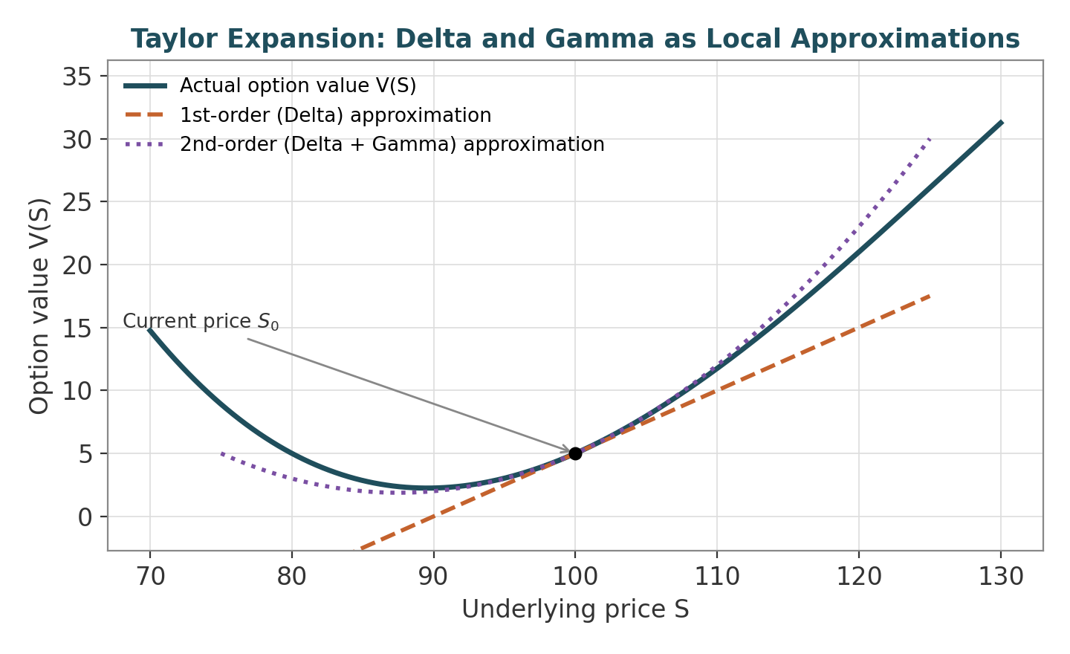
Figure 2.1 — The tangent line (delta) approximates the curve only locally; adding the gamma term bends the approximation to track the true curve over a wider range.

2.3 Worked Example — Taylor Approximation of Option P&L
- Let ΔS be a small move in the underlying price. The second-order Taylor expansion of the P&L is: ΔV ≈ Δ · ΔS + ½ · Γ · (ΔS)², where Δ is delta and Γ is gamma.
- Suppose an option has Δ = 0.50 and Γ = 0.04, and the underlying moves by ΔS = +$2.
- First-order (delta-only) estimate: ΔV ≈ 0.50 × 2 = $1.00.
- Adding the second-order (gamma) term: ΔV ≈ 1.00 + ½ × 0.04 × 2² = 1.00 + 0.08 = $1.08.
- The gamma term captures the curvature that a linear (delta-only) estimate misses — the larger the price move, the more this second-order term matters, which is why large moves make delta-only hedges unreliable.

2.4 Worked Example — Gradient of a Two-Factor P&L Function
- Suppose a position's value depends on two risk factors: the underlying price S and implied volatility σ, with delta Δ=0.50 and vega ν=0.12 (P&L per 1-point move in volatility) at the current point.
- The gradient of the value function is the vector ∇V = (∂V/∂S, ∂V/∂σ) = (0.50, 0.12).
- For a simultaneous move of ΔS = +2 and Δσ = −1 (price up, volatility down), the first-order multivariable Taylor approximation gives: ΔV ≈ ∇V · (ΔS, Δσ) = 0.50×2 + 0.12×(−1) = 1.00 − 0.12 = $0.88.
- This is exactly how a real-time risk system aggregates P&L across many simultaneous factor moves: it takes the dot product of the position's sensitivity vector (its gradient) with the vector of factor moves — no repricing required, only the pre-computed Greeks.

2.5 Reference Table — Key Formulas
Object | Mathematical Definition | Financial Meaning
Derivative | dV/dS = limₕ→0 [V(S+h)−V(S)] / h | Instantaneous rate of change (Delta)
Partial derivative | ∂V/∂σ | Sensitivity to one variable holding others fixed (Vega)
Second derivative | ∂²V/∂S² | Curvature of price sensitivity (Gamma)
Gradient | ∇f = (∂f/∂x₁, …, ∂f/∂xₙ) | Direction of steepest increase (used in optimisation)
Taylor expansion (2nd order) | f(x+h) ≈ f(x) + f′(x)h + ½f″(x)h² | Local P&L approximation via Greeks
Chain rule | d/dx f(g(x)) = f′(g(x))·g′(x) | Propagating sensitivity through composed pricing functions

3. Linear Algebra (Level 1)
Covers: Vectors · matrices · matrix multiplication · inverses · rank · eigenvalues/eigenvectors · positive-definite matrices · covariance matrices · matrix decompositions · PCA
▸ INTUITION FIRST
A covariance matrix is nothing more than a table of “how much do these two things move together” numbers. Portfolio risk is what you get when you weight and sum every entry in that table — which is exactly what the matrix formula wᵀΣw does. Eigenvectors then just find the directions in that table where the co-movement is strongest and weakest.

3.1 Learning Position at a Glance
- What it is: The mathematics of vectors and matrices, used to represent portfolios, covariance structures and multi-asset relationships.
- Why it matters: Portfolio variance, risk decomposition, factor models and PCA are all matrix operations; there is no shortcut around this for multi-asset work.
- Prerequisites: Algebra.
- Connects to Research: PCA and eigen-decomposition are standard tools for factor extraction and dimensionality reduction.
- Connects to Development: Efficient matrix computation (vectorisation, BLAS-backed libraries) is central to performant research code.
- Connects to Trading: Portfolio-level risk (covariance matrix) determines diversification benefit and hedge ratios.
- Practical exercise: Compute the variance of a 5-asset portfolio using the full covariance matrix by hand for a small example, then verify with NumPy.
- Common beginner mistakes:
  - Treating a covariance matrix as if it were always positive-definite (it can be singular with insufficient data).
  - Confusing eigenvector direction with eigenvalue magnitude when interpreting PCA factors.
- Advanced extensions: Matrix decompositions (Cholesky, SVD) for simulation and robust optimisation.
- Professional applications: Portfolio variance/risk decomposition; factor-model construction; risk-parity weighting.

3.2 Concept Walkthrough
A portfolio's risk is not just the weighted average of individual asset volatilities — it depends on how assets move together, which is captured entirely by the covariance matrix Σ. Portfolio variance is the single-line formula wᵀΣw, where w is the vector of portfolio weights. This is why linear algebra, not just arithmetic, is unavoidable once a portfolio has more than one asset.
It is worth unpacking why wᵀΣw is the right formula rather than just memorising it. Portfolio variance is, by definition, Var(Σᵢ wᵢRᵢ) where Rᵢ are the individual asset returns. Expanding this variance of a sum gives a double sum over every pair of assets: ΣᵢΣⱼ wᵢwⱼ Cov(Rᵢ,Rⱼ). That double sum — weight times weight times covariance, summed over every pair — is precisely what matrix multiplication wᵀΣw computes in one compact expression. The matrix notation is not a shortcut hiding complexity; it is a compact way of writing exactly that pairwise sum, with the diagonal of Σ (each asset's own variance) and the off-diagonals (pairwise covariances) both included automatically.
The chart below shows the direct consequence for a real two-asset portfolio: as the correlation between the two assets falls from +1 toward −1, portfolio volatility falls well below the simple weighted-average volatility of the two assets on their own. This gap is the diversification benefit, and it is a pure consequence of the off-diagonal covariance terms in the wᵀΣw formula — there is no diversification benefit at all when correlation is exactly +1, because then the portfolio behaves as if it held only one asset.
Eigen-decomposition of Σ is the basis of Principal Component Analysis (PCA): it re-expresses the covariance structure as a set of uncorrelated “factors,” ordered by how much variance each explains. Concretely, an eigenvector v of Σ is a direction in “asset space” along which returns move together as a single combined bet, and its eigenvalue λ tells you how much variance that combined bet accounts for. The eigenvector gives the direction (the factor's composition across assets, i.e. how much of each asset the factor combines); the eigenvalue gives the magnitude (how much variance that direction explains). Beginners often swap these two roles when interpreting PCA output — remember: direction from the vector, size from the value.
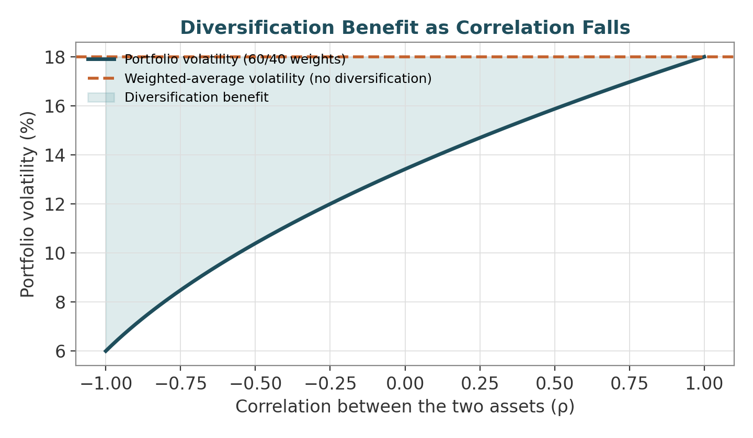
Figure 3.1 — As correlation falls, the off-diagonal covariance term shrinks (and eventually turns negative), pulling portfolio volatility below the simple weighted average.
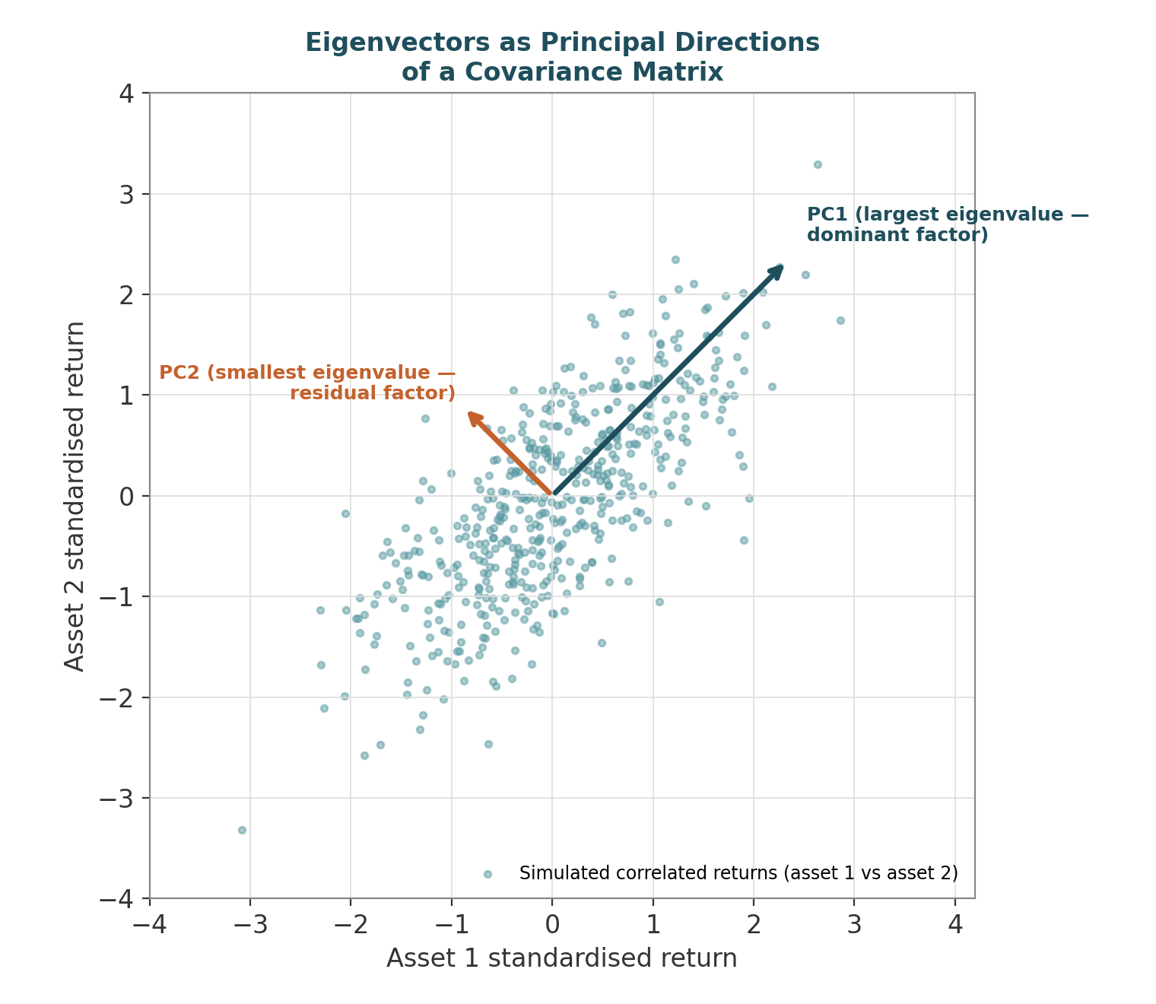
Figure 3.2 — The first eigenvector (PC1) points along the direction of strongest joint co-movement between the two assets; the second (PC2), perpendicular to it, captures the leftover, weaker variation.

3.3 Worked Example — Two-Asset Portfolio Variance
- Two assets have standard deviations σ₁ = 20%, σ₂ = 15%, and a correlation ρ = 0.30. Portfolio weights are w₁ = 0.60, w₂ = 0.40.
- Covariance matrix: Σ = [[0.04, 0.009], [0.009, 0.0225]], where the off-diagonal term is ρ×σ₁×σ₂ = 0.30×0.20×0.15 = 0.009.
- Portfolio variance: wᵀΣw = 0.60²(0.04) + 0.40²(0.0225) + 2(0.60)(0.40)(0.009) = 0.0144 + 0.0036 + 0.00432 = 0.02232.
- Portfolio volatility: √0.02232 ≈ 14.94% — notice this is lower than the simple weighted-average volatility (0.6×20% + 0.4×15% = 18%), which is the mathematical expression of diversification benefit.

3.4 Worked Example — Eigenvalues and Eigenvectors of a 2×2 Covariance Matrix
- Using the same covariance matrix Σ = [[0.04, 0.009], [0.009, 0.0225]], the eigenvalues λ solve det(Σ − λI) = 0: (0.04−λ)(0.0225−λ) − 0.009² = 0.
- Expanding: λ² − 0.0625λ + 0.00081 = 0. Solving the quadratic gives λ₁ ≈ 0.0455 and λ₂ ≈ 0.0170.
- The eigenvalues sum to 0.0625, which exactly equals the trace of Σ (0.04 + 0.0225) — a useful check: the total variance in the system is conserved, just re-partitioned across the two orthogonal factor directions.
- For λ₁ ≈ 0.0455, solving (Σ − λ₁I)v = 0 gives an eigenvector proportional to (0.83, 0.55) after normalising — a direction weighted mostly toward asset 1, since asset 1 has the larger individual variance. This is PC1: the dominant, largest-variance factor. The second eigenvector, perpendicular to the first, is PC2 and explains the remaining, smaller share of variance (λ₂ / (λ₁+λ₂) ≈ 27%).

3.5 Reference Table — Key Formulas
Concept | Formula | Role in Finance
Portfolio variance | σ²ₚ = wᵀΣw | Total portfolio risk given weights w
Covariance | Cov(i,j) = ρᵢⱼσᵢσⱼ | Co-movement between assets i and j
Eigen-decomposition | Σv = λv | PCA factor direction (v) and magnitude (λ)
Trace identity | Σᵢλᵢ = trace(Σ) | Total variance is conserved across PCA factors
Positive-definite check | xᵀΣx > 0 for all x≠0 | Whether Σ is a valid, invertible covariance matrix
Cholesky decomposition | Σ = LLᵀ | Used to simulate correlated random returns

4. Optimisation (Level 1)
Covers: Objective functions · constraints · convexity · Lagrange multipliers · gradient descent · quadratic programming · convex optimisation
▸ INTUITION FIRST
Optimisation is just calculus with rules attached: find where the slope is zero (calculus), but only among points that satisfy the constraints. Convexity is the property that guarantees there's only one “bottom of the bowl” to find — without it, a solver can get stuck in a local dip that isn't the true best answer.

4.1 Learning Position at a Glance
- What it is: The mathematics of finding the best solution to a problem subject to constraints.
- Why it matters: Portfolio construction is fundamentally a constrained optimisation problem (maximise return/minimise risk subject to exposure limits).
- Prerequisites: Calculus; Linear Algebra.
- Understand before proceeding: Do not run a portfolio optimiser before covariance estimation and basic risk concepts are understood — optimisers amplify estimation error into extreme, unstable weights.
- Connects to Research: Mean-variance and risk-parity portfolio construction are direct optimisation applications.
- Connects to Development: Solvers (quadratic programming libraries) must be integrated correctly, with sensible constraint handling and numerical stability checks.
- Connects to Trading: Position sizing under exposure and turnover limits is a live optimisation problem.
- Practical exercise: Formulate and solve a minimum-variance portfolio with a long-only constraint using a quadratic programming solver, and compare it to the unconstrained solution.
- Common beginner mistakes:
  - Ignoring estimation error in inputs and trusting optimiser output literally.
  - Using unconstrained mean-variance optimisation on noisy return estimates and getting extreme, unstable weights.
- Advanced extensions: Robust optimisation, Black-Litterman, and CVaR optimisation (Level 3).
- Professional applications: Portfolio construction; hedge-ratio calculation; capital allocation across strategies.

4.2 Concept Walkthrough
Portfolio optimisation is the textbook example of constrained optimisation: minimise portfolio variance wᵀΣw subject to constraints such as weights summing to 1 (fully invested), weights ≥ 0 (long-only), or exposure limits per sector. Lagrange multipliers turn a constrained problem into an unconstrained one by attaching a penalty term for each constraint: instead of minimising f(w) subject to g(w)=0, you minimise the Lagrangian L(w,λ) = f(w) − λ·g(w) with no constraint at all. Setting ∇L = 0 with respect to both w and λ simultaneously finds the constrained optimum — the multiplier λ itself has a real interpretation as the “shadow price” of the constraint (how much the objective would improve if the constraint were relaxed slightly).
Convexity matters enormously here because it is what guarantees a solver actually finds the best answer rather than a merely locally good one. A convex function looks like a single bowl: wherever you start searching from, walking downhill always leads to the same global minimum. A non-convex function can have several separate dips (local minima), and a solver that only knows how to walk downhill can get trapped in a dip that isn't the deepest one available. The chart below contrasts the two cases directly. The mean-variance objective wᵀΣw is convex whenever Σ is positive semi-definite (which any valid covariance matrix is), which is precisely why classical portfolio optimisation is tractable and why solvers can guarantee a global optimum.
In practice, exact closed-form solutions rarely survive contact with real constraints (no short-selling, position caps, turnover limits), so numerical solvers — quadratic programming (QP) for the mean-variance case, or gradient descent for more general objectives — are used instead. Gradient descent works by repeatedly stepping in the direction opposite the gradient (−∇f), since the gradient points toward the steepest increase and its negative therefore points toward the steepest decrease; taking small enough steps in that direction is guaranteed to reduce a convex objective until it reaches the minimum.
A critical, often-overlooked point: because covariance and expected-return estimates are noisy, an optimiser will happily exploit that noise, producing extreme long/short positions that look optimal in-sample but perform poorly out-of-sample. This is not a bug in the mathematics — the optimiser is doing exactly what it was asked to do (find the absolute best combination given the numbers it was handed); the problem is that the numbers themselves carry estimation error, and the optimiser's job is precisely to seek out and lean hardest on whatever looks best, including any noise that only looks like signal.
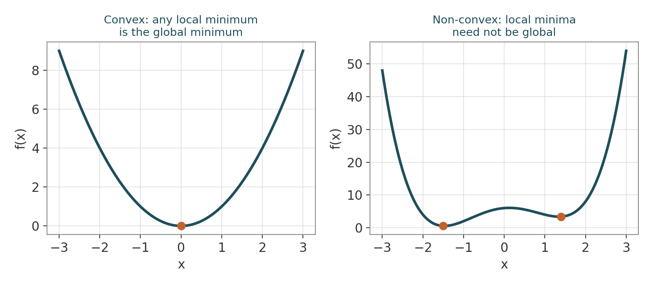
Figure 4.1 — A convex objective (left) has one bowl, so any local minimum is the global minimum; a non-convex objective (right) can trap a solver in a shallower, non-optimal dip.
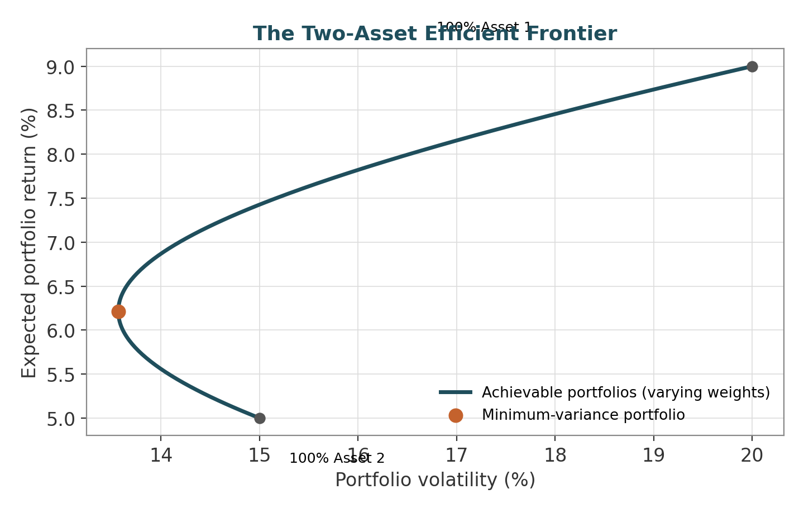
Figure 4.2 — Every point on the curve is the lowest-risk portfolio achievable for its level of return; the minimum-variance point is where the curve bends back on itself.

4.3 Worked Example — Minimum-Variance Weights, Unconstrained vs. Long-Only
- Using the same two-asset covariance matrix as the Linear Algebra example (σ₁=20%, σ₂=15%, ρ=0.30), the unconstrained minimum-variance weight formula for two assets is w₁* = (σ₂² − Cov₁₂) / (σ₁² + σ₂² − 2Cov₁₂).
- Plugging in: w₁* = (0.0225 − 0.009) / (0.04 + 0.0225 − 0.018) = 0.0135 / 0.0445 ≈ 0.303, so w₂* ≈ 0.697.
- Both weights are positive here, so the long-only constraint (w ≥ 0) is not binding — the unconstrained and constrained solutions coincide in this example.
- If asset 2's volatility were instead very low and its correlation with asset 1 strongly negative, the unconstrained formula could produce w₁* < 0 (a short position). Under a long-only constraint, a QP solver would instead push that weight to exactly 0 and re-solve over the remaining assets — illustrating why constrained and unconstrained optima can diverge sharply.

4.4 Worked Example — Deriving the Minimum-Variance Weight with a Lagrange Multiplier
- Problem: minimise portfolio variance f(w₁) = w₁²σ₁² + (1−w₁)²σ₂² + 2w₁(1−w₁)Cov₁₂ subject to the single constraint that weights sum to 1 (already built in by substituting w₂ = 1−w₁, so no explicit multiplier is even needed for this simple two-asset case).
- Take the derivative with respect to w₁ and set it to zero: df/dw₁ = 2w₁σ₁² − 2(1−w₁)σ₂² + 2(1−2w₁)Cov₁₂ = 0.
- Rearranging collects all w₁ terms on one side: w₁(σ₁² + σ₂² − 2Cov₁₂) = σ₂² − Cov₁₂, giving exactly the closed-form formula used in the first worked example — confirming that the “formula” is really just the first-order condition (derivative = 0) of a calculus minimisation problem.
- With three or more assets, the equality constraint Σwᵢ=1 can no longer be eliminated by simple substitution, which is where an explicit Lagrange multiplier λ becomes necessary: minimise wᵀΣw − λ(Σwᵢ − 1), differentiate with respect to every wᵢ and λ, and solve the resulting linear system — this is exactly what a portfolio-optimisation library does under the hood for the unconstrained (no long-only, no caps) case.

4.5 Reference Table — Key Formulas
Term | Meaning | Example Use
Objective function | Quantity to minimise or maximise | Minimise wᵀΣw (portfolio variance)
Constraint | Restriction the solution must satisfy | Σwᵢ = 1 (fully invested)
Convexity | A function where a local minimum is the global minimum | Mean-variance objective is convex
Lagrange multiplier | Shadow price attached to a constraint | Used to derive closed-form min-variance weights
Gradient descent step | w ← w − η∇f(w) | Iteratively finds a minimum when no closed form exists
Quadratic programming (QP) | Solver for quadratic objective + linear constraints | Standard tool for portfolio optimisation

5. Stochastic Mathematics (Introductory Awareness Only) (Level 1 (awareness) → Level 5 (depth))
Covers: Random processes · Brownian motion · martingales · stochastic differential equations · Itô's lemma · stochastic calculus
▸ INTUITION FIRST
Think of a coin-flip random walk taken to its extreme: flip infinitely fast, for infinitesimally small steps. What you get is Brownian motion — still fundamentally “random up-or-down,” just smoothed into continuous time. Every advanced object in this topic (martingales, SDEs, Itô's lemma) is built on that same coin-flip intuition; only the bookkeeping gets more sophisticated.

5.1 Learning Position at a Glance
- What it is: Mathematics of randomness evolving through time — the foundation of continuous-time derivatives pricing.
- Why it matters: Black-Scholes and all continuous-time derivatives models are built on stochastic calculus; but it is only meaningful once calculus, probability and statistics are solid.
- Prerequisites: Calculus (Depth 3+), Probability (Depth 2+), Statistics (Depth 2+).
- Understand before proceeding: Do not learn stochastic calculus before calculus and probability are solid — see the Level 1 “Do Not Learn Yet” guardrail. At Level 1, only acquire the vocabulary; defer derivation to Level 5.
- Connects to Research: Not typically used directly in empirical alpha research; relevant mainly for derivatives/volatility research.
- Connects to Development: Simulation engines (Monte Carlo) implement discretised stochastic processes.
- Connects to Trading: Options and volatility trading desks reason about risk using these models directly.
- Practical exercise: At Level 1, simply simulate a discrete random walk in Python and observe its resemblance to Brownian motion — defer Itô's lemma to Level 5.
- Common beginner mistakes:
  - Attempting to learn Itô's lemma before basic calculus and probability are fluent.
  - Treating stochastic calculus as necessary for all quant roles — it is primarily relevant to derivatives/volatility specialisation.
- Advanced extensions: Full treatment under Level 5 — Advanced Derivatives / Volatility.
- Professional applications: Options pricing; volatility modelling; risk-neutral valuation.

5.2 Concept Walkthrough
At Level 1 the goal is vocabulary, not derivation. A stochastic process is simply a variable that evolves randomly through time; Brownian motion is the continuous-time analogue of a random walk, with independent, normally-distributed increments. A martingale is a process whose expected future value, given everything known today, equals today's value — the mathematical formalisation of a “fair game” with no predictable drift.
The chart below shows twelve independent discrete random walks, each built from nothing more complicated than a sequence of coin flips (+1 or −1 with equal probability, added up over time). Even though the underlying rule is trivially simple, the resulting paths already look strikingly similar to real asset-price charts — jagged, unpredictable, with no obvious pattern to exploit. This resemblance is not a coincidence: it is the entire motivation for using random-walk-based models (and, in the continuous-time limit, Brownian motion) to describe how prices evolve.
Itô's lemma is the stochastic-calculus equivalent of the chain rule, but with an extra term arising because Brownian motion is nowhere differentiable in the ordinary sense — it is so jagged, at every scale, that the usual definition of a derivative (the limit of a slope) simply does not exist for it. The extra “Itô term” exists precisely to correct for this: it accounts for the fact that the variance of a Brownian increment, unlike an ordinary infinitesimal, does not vanish as the time step shrinks. This is precisely why Itô's lemma must wait until calculus and probability are fluent — without that foundation, the extra term appears to come from nowhere. This topic is deliberately left shallow here; full treatment resumes at Level 5.
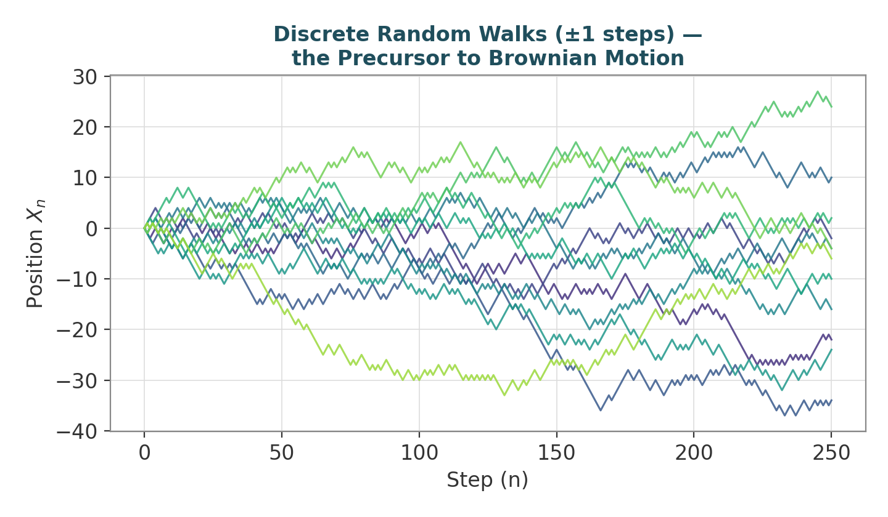
Figure 5.1 — Twelve independent ±1 random walks. As the step size shrinks and the number of steps grows, paths like these converge to Brownian motion.

5.3 Worked Example — Discrete Random Walk as a Precursor to Brownian Motion
- Define a discrete random walk: at each step, the value moves up or down by a fixed amount Δx with equal probability. After n steps starting at 0, the position is Xₙ = Δx × (U₁ + U₂ + … + Uₙ), where each Uᵢ = +1 or −1 with probability ½.
- As the step size shrinks and the number of steps grows (Δx → 0, n → ∞, with n·Δx² held constant), this discrete walk converges to Brownian motion — a continuous process with independent, normally distributed increments.
- At Level 1, the exercise is only to generate such a walk in Python (e.g. cumulative sum of random ±1 steps) and observe visually that it looks like the jagged, unpredictable paths seen in asset-price charts — the formal proof of convergence and Itô's lemma are deferred entirely to Level 5.

5.4 Worked Example — Why the Random Walk's Spread Grows with √n, not n
- Each step Uᵢ has mean 0 and variance 1 (it is +1 or −1 with equal probability). Since the steps are independent, variances add: Var(Xₙ) = Var(U₁) + … + Var(Uₙ) = n.
- So the standard deviation of the walk's position after n steps is √n, not n. After 4 steps the typical spread is about 2; after 100 steps it is only about 10, not 100.
- This √n scaling is the discrete-time cousin of one of the most important facts in continuous-time finance: volatility scales with the square root of time (a direct consequence of Brownian motion's variance growing linearly with t), which is why annualising volatility multiplies by √252 (trading days) rather than by 252 itself.

5.5 Reference Table — Key Formulas
Term | Informal Meaning | Where It Reappears
Stochastic process | A variable evolving randomly over time | Asset price models
Brownian motion | Continuous-time random walk with normal increments | Black-Scholes model
Martingale | A process with no predictable drift, given current information | Risk-neutral pricing
Stochastic differential equation (SDE) | An equation describing a randomly evolving quantity | dS = μS dt + σS dW
Itô's lemma | Chain rule for functions of stochastic processes | Deriving the Black-Scholes PDE
√t scaling | Standard deviation of a random walk grows with √(time) | Annualising volatility (×√252)

